**(16) Temperature Pattern**

Temperature pattern of the surface of earth

The factor affecting the temperature pattern of the earth.

1. Continentality.
2. Latitude.
3. altitude.
4. Cloud cover.
5. Wind / upwelling
6. Slope
7. conventional
8. Ocean currents

The solar intensity varies with the latitude. The temperature of place depends on latitude at low latitudes the sunrays nearly vertically. The loss of sun rays is relatively lower for short distances. Is converted by the sun rays through the atmosphere. And a small area on the surface is covered therefore there is concentration of energy.

High latitude slant sun rays the long distance covered by the sun ray’s greater loss of energy and greater distance covered on the area of earth therefore energy is less concentrated. Because of all these factors low latitudes received lower intensity as compared to higher latitude which intern affect the temperature patten.

Overall, in general the temperature is reduced from the equator to the pole. This is called latitude control of temperature. How ever the equator is not the warmest. However, the tropics are warmest.

Equator has greater cloud cover therefore more albedo. (reflectivity)

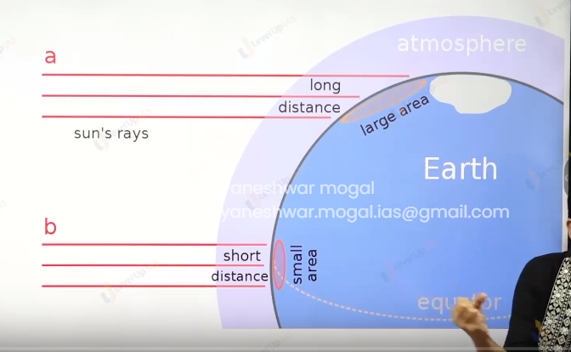

Q.

statement 1. temperature contrast is greater between continent and ocean in the winter.

Statement 2. Specific heat of water is more than that of land surface.

Options

1. Both 1 and 2 are correct, 2 is explanation of the statement 1.
2. Both 1 and 2 are correct, but 2 is not correct explanation of the statement 1
3. Statement 2 is correct and the other is incorrect.
4. Statement 1 is correct and other is incorrect.

Option c

Water take time to heat. So specific heat is more. In winter the sun energy is now the contrast / difference is also low in winter.

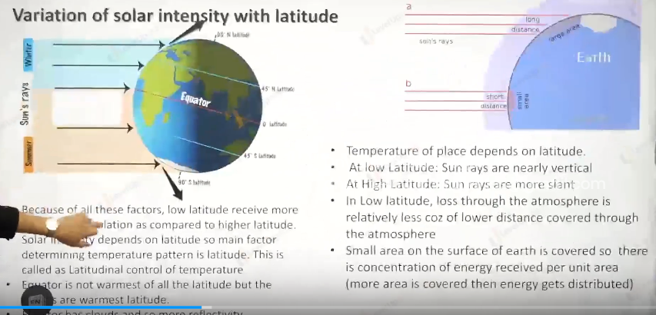

From the data of the ncrt the answer might be 1 both are correct and explain also.

Altitude mimics latitude.

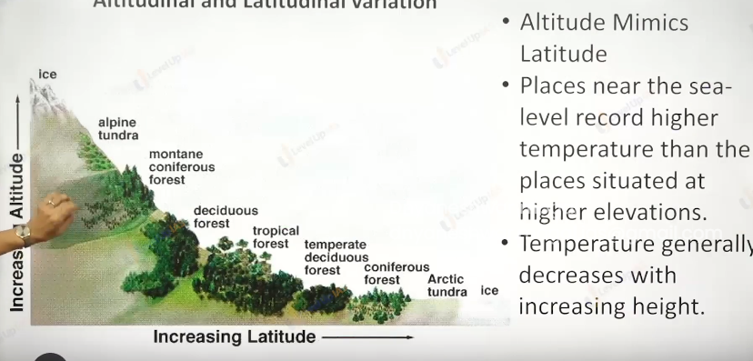

As we move high in the altitude the temperature reduces.

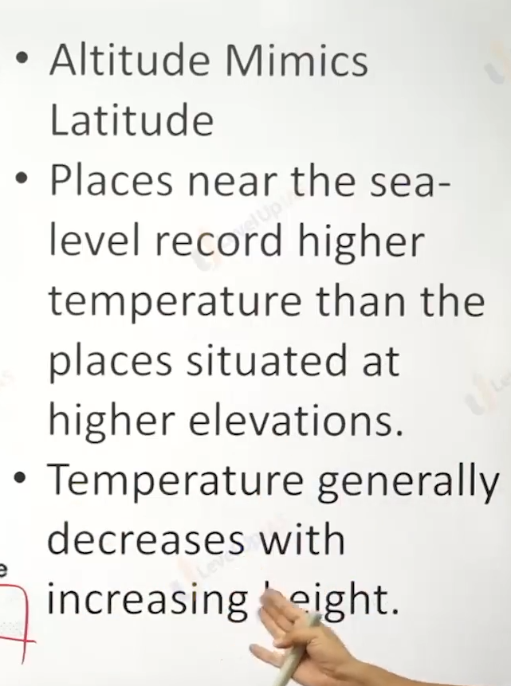

Continentality: (moderating influence of sea.)

1. Compared to land, water heats up slowly and cools slowly. It has more specific heat therefore there is more variation in the temperature over land than over ocean.

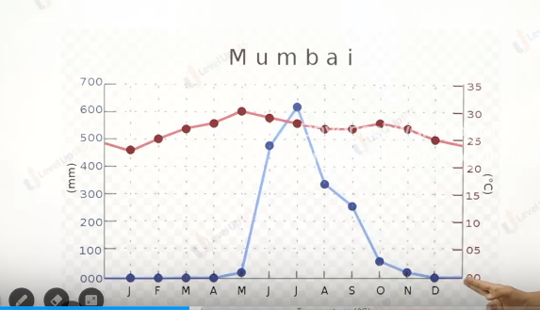

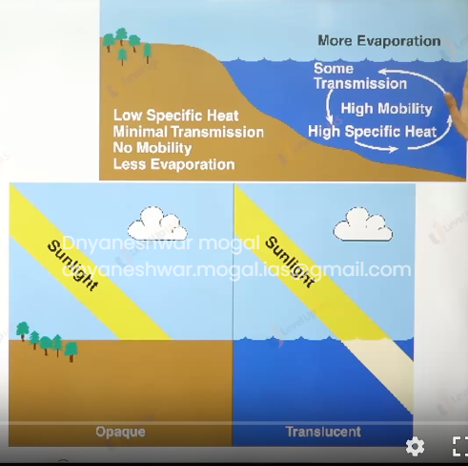

Effects of ocean current:

1. Warm ocean current increases the temperature of the place ex Norwegian sea current whereas cold ocean current reduces the temperature of current. Ex Labrador current.

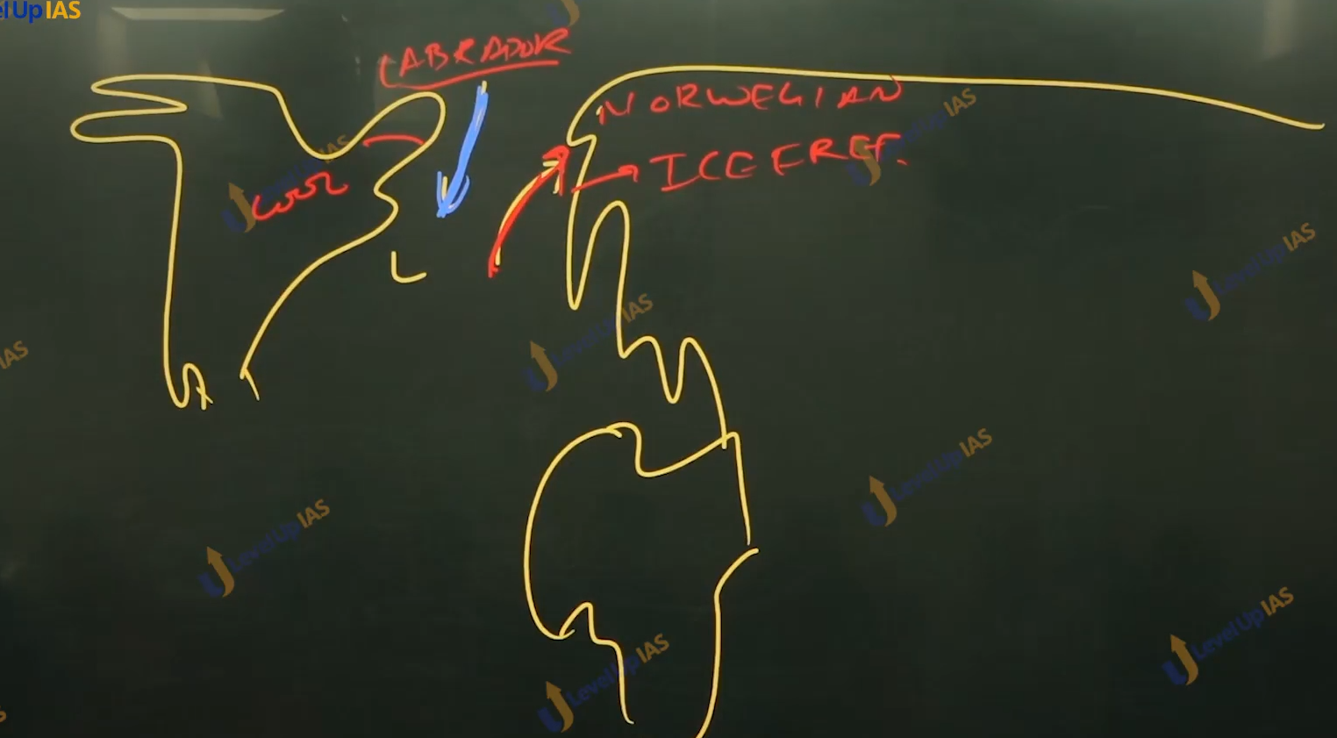

Effects of the winds:

1. Warm wind increases the temperature of the place ex. Clunuk lou, whereas cold winds reduce the temperature of places. Ex. Bora mitral.

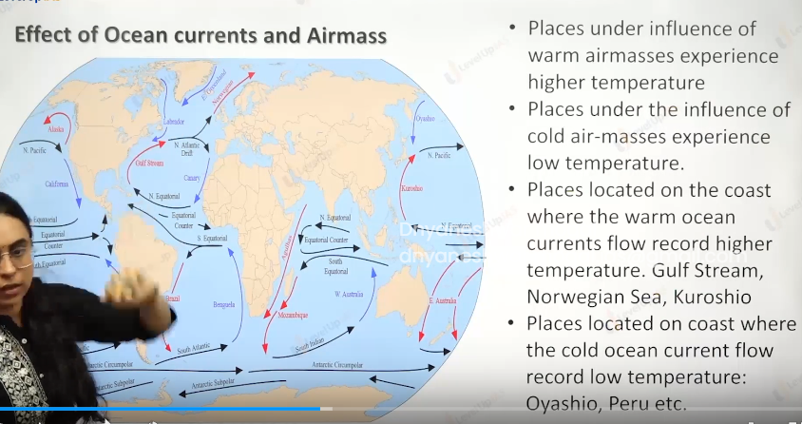

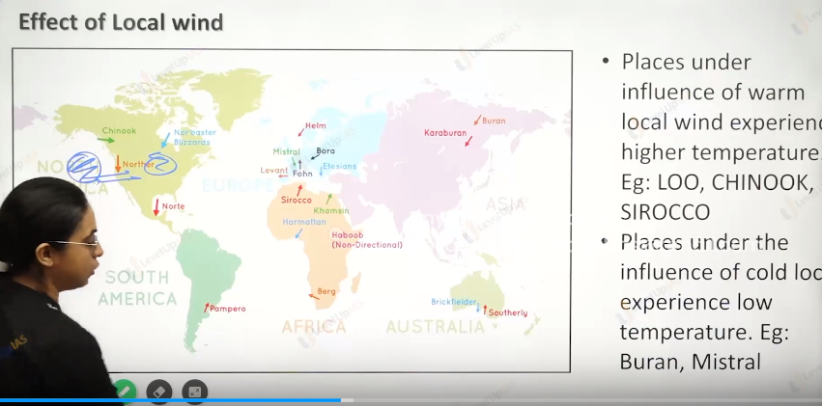

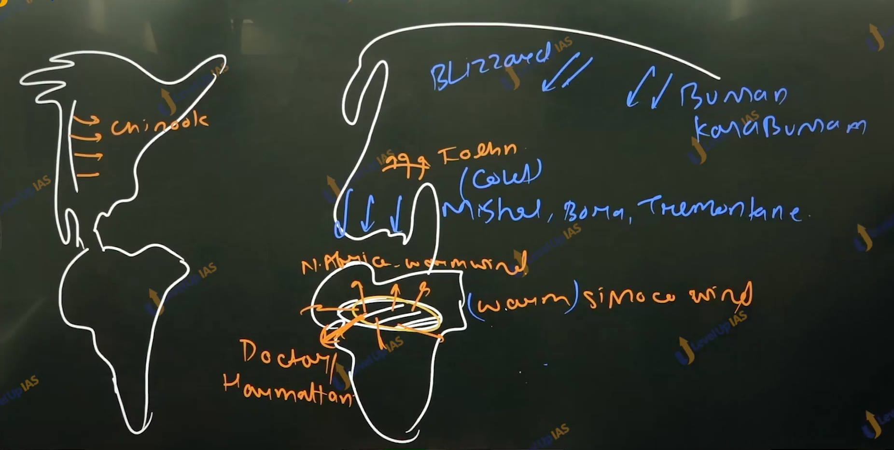

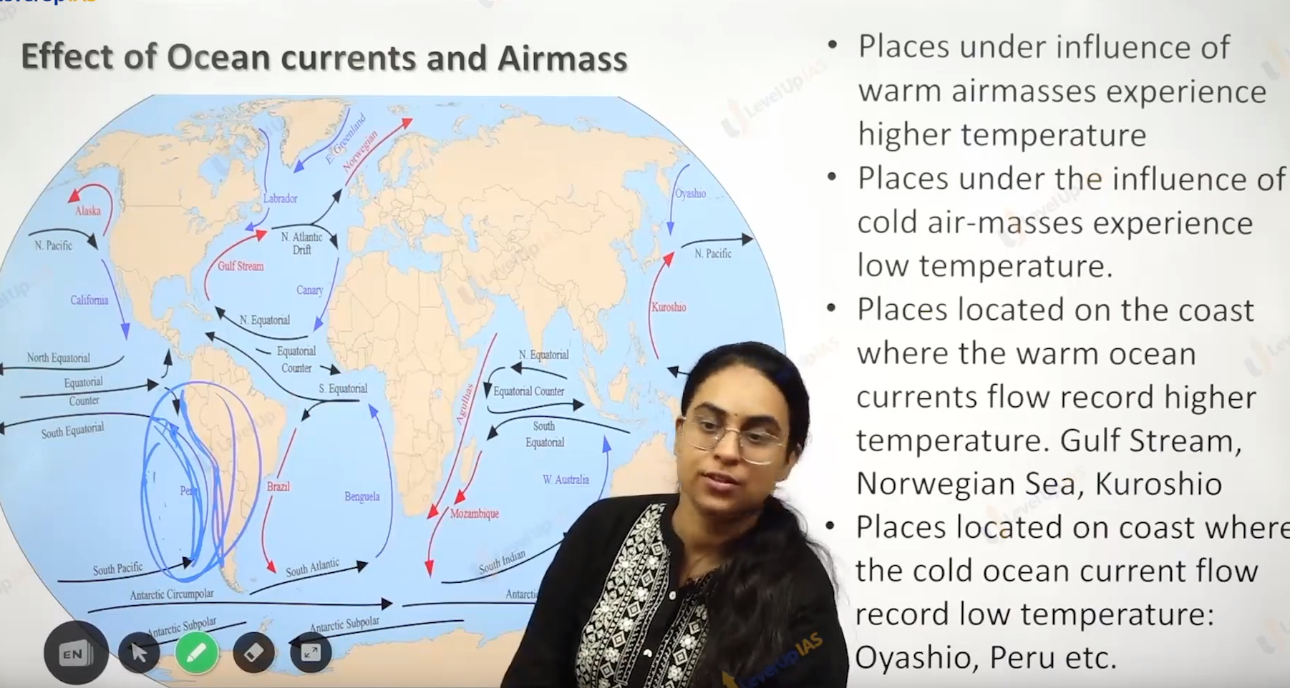

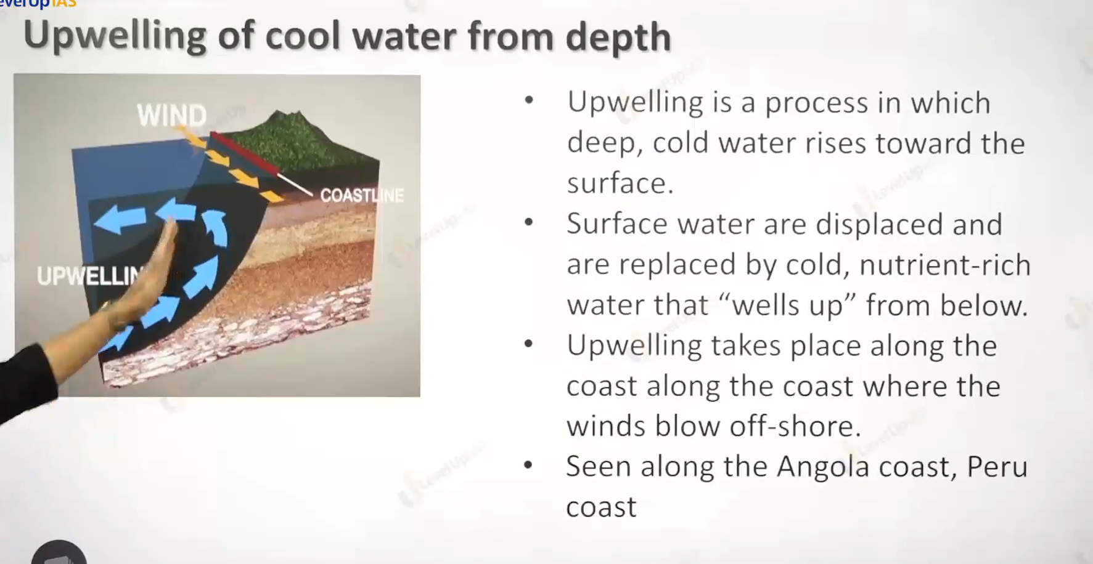

Upwelling:

1. Upwelling is the process in which deep cold water raises words the surface water. Upwelling takes places along the coast where the wind blows offshore where the wind blows from land to sea.
2. Upwelling is caused as the surface wind blow the surface water away from the coast does displacing the surfaces water the places of surfaces water is occupied by the cold nutrient rich water this seen along the Peru coast, Angola coast, best Australian coast, Californian coast.

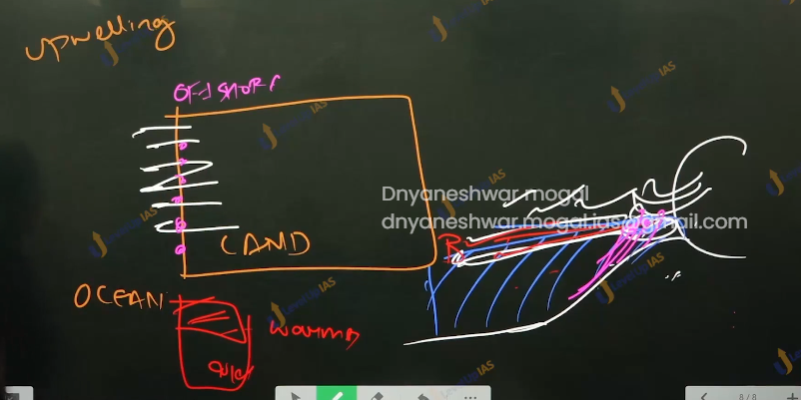

Factor affecting temperature patten

1. the slope condition.

1. The sun facing slope is called as adrat slope and slope facing away the sun is ubac slope
2. The adrat slope has more temperature than ubac slope
3. The southern slope is adrat and northern slope Is ubac slope.

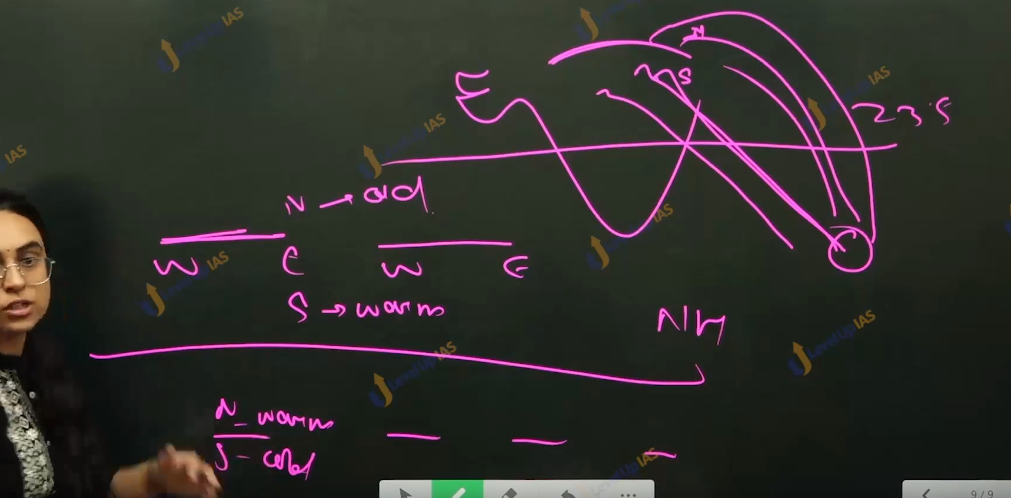

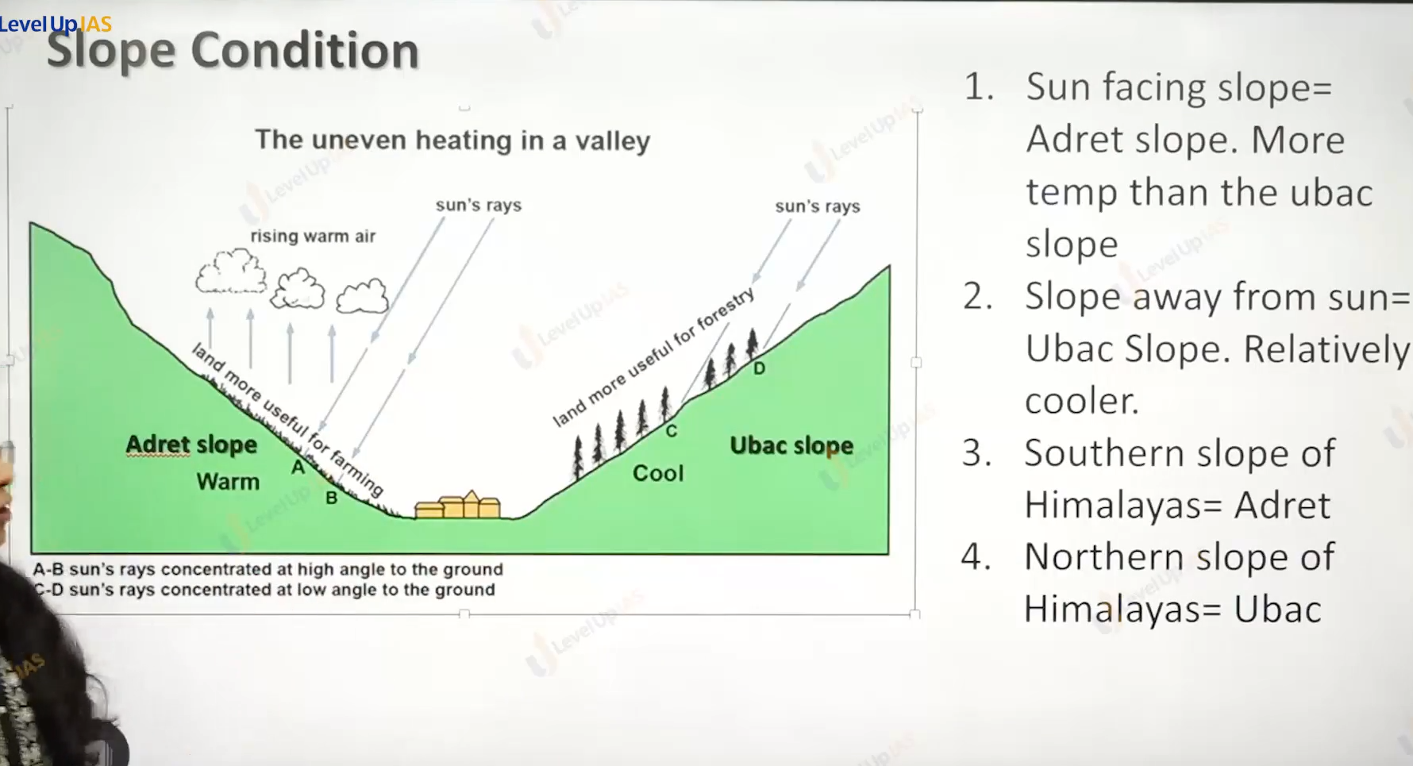

2. Temperature inversion.

1. Normally the temperature decreases with an increase in elevation. It is called normal lapse conditions. But there are situations where the conditions are reversed, and the normal lapse rate is inverted it called as inversion of temperature (temperature increases with increase in height up to certain height. Inversion is of short duration.
2. Winter inversion:
   1. A long winter night with clear skies and still air is ideal for temperature inversion.
   2. The heat of day is radiated off during night by early morning hours the air is cooler than air above.
   3. Just above the earth surface it will become the cool and the warm air would over lie cold air.
   4. Over the polar reason temperature inversion is normal throughout the year, how ever in the tropical reason it seen in the winter season
   5. The inversion lasts only for few hours till the time span appears and starts warming the earth’s surfaces again.
3. Temperature inversion promotes stability in the lower region of the atmosphere.
4. Dance fogs are common, and dewdrop found on the plant and colder surfaces, dust and smoke are collected beneath the inversion layer it will smog like conditions.

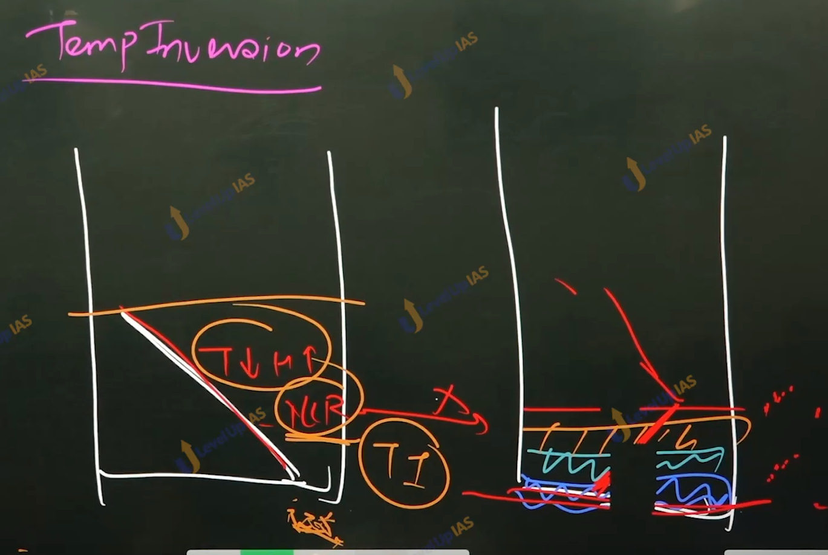

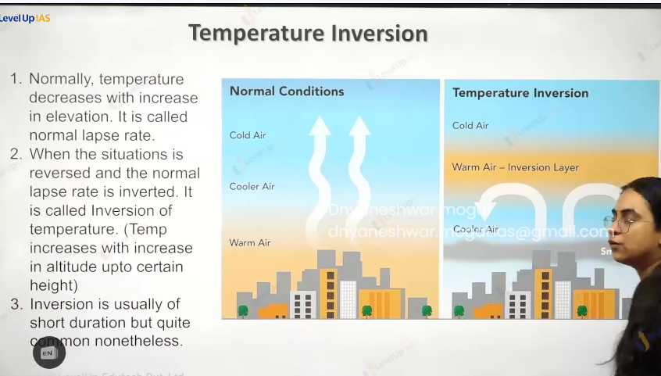

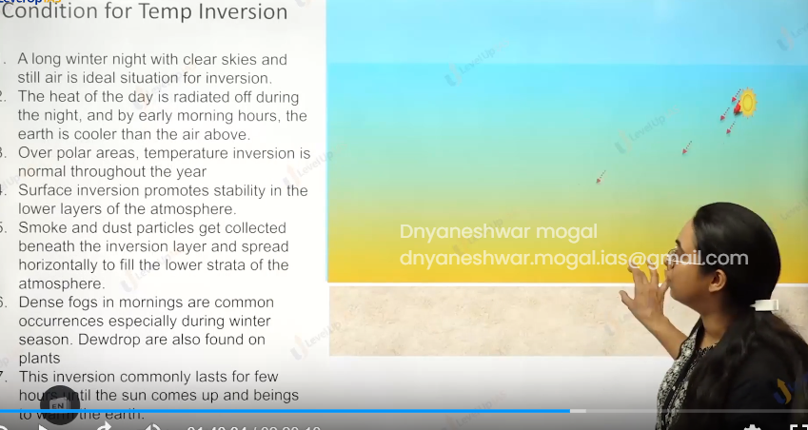

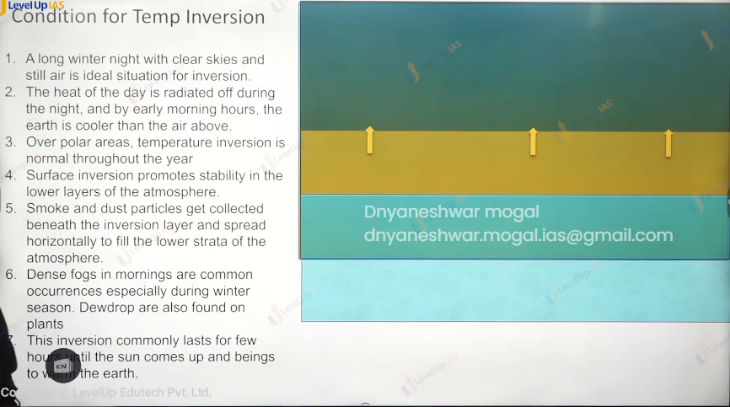

Mountain conditions:

Mountain inversion:

1. Inversion that takes places in the heels and mountains. Due to air drainage.
2. Cold air of hill and mountains produced during the night flow down under the influence of gravity being heavy and dance the cold air moves down the slope to pile up in the deep valleys and pushes the warm air above leading to temperatures inversion.

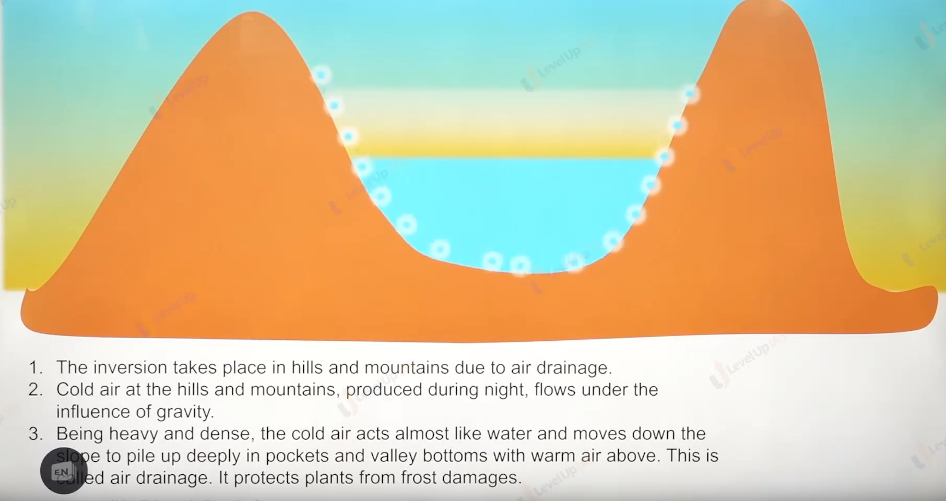

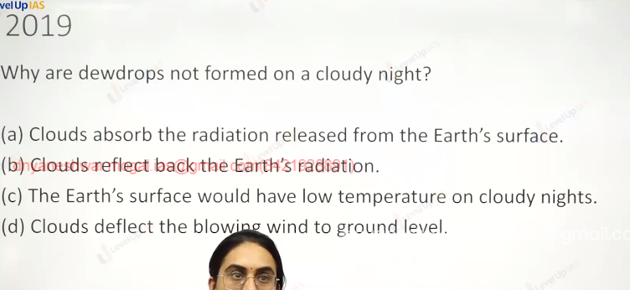

Option b) reflection radiation will warm the planet. Option c and a indicate the formation of dews.

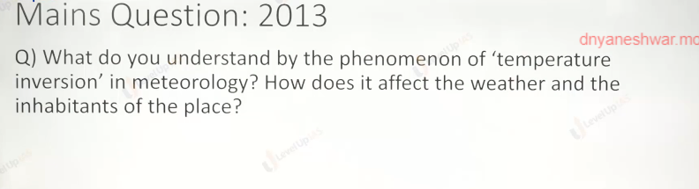

Pressure conditions:

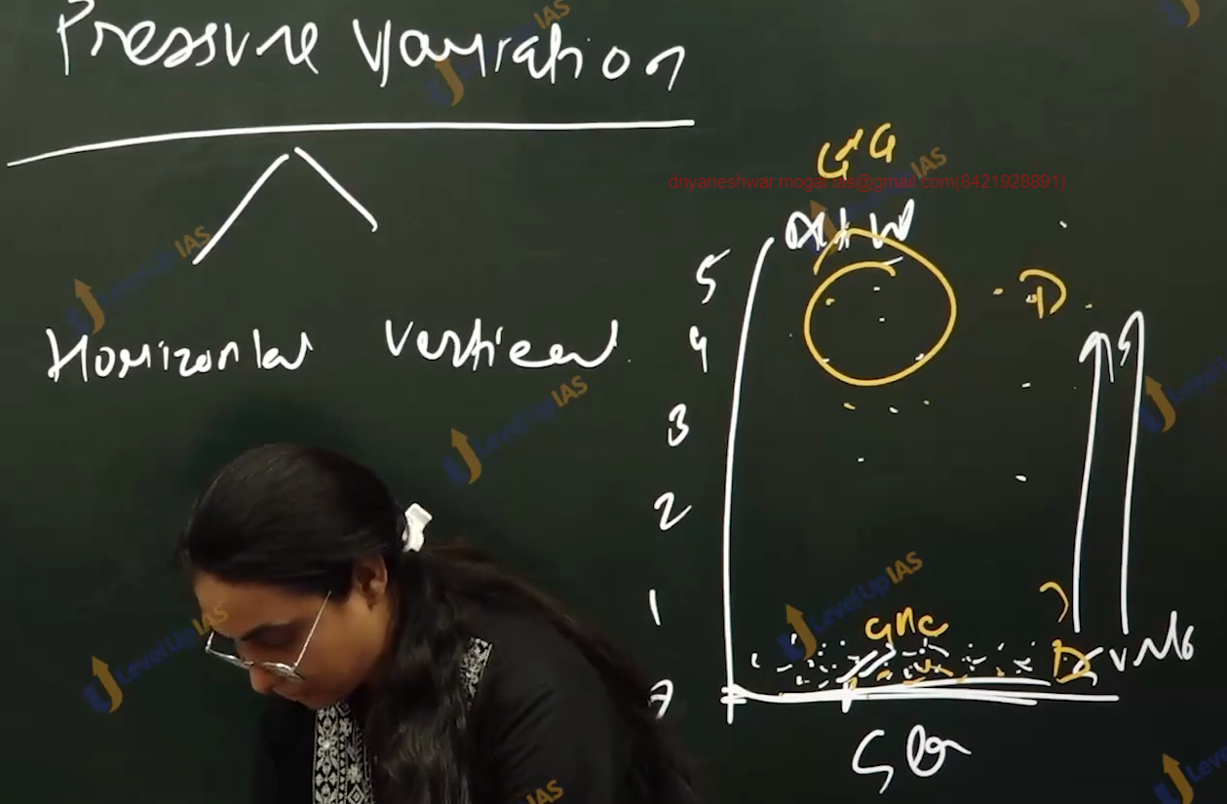

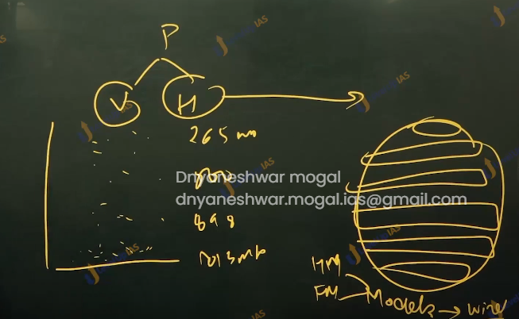

1. There are 7 pressure variation.
2. There are 2 types of pressure variation horizontal, and vertical. Near the sea level there is more atmospheric pressure while the pressure decreases with the increases in height.
3. At zero km (sea level) height the pressure is about 1013 mb at 1 km it about 898 mb at 10 km the pressure is 256 mb.
4. There are also horizontal pressure variations on the surface of the earth which can be understood with the various models.
5. It is important to understand pressure variations as affects the movement of air and winds. it pressures that determines whether there would be vertical movement or not.

There

